Landlord enquiry testing:
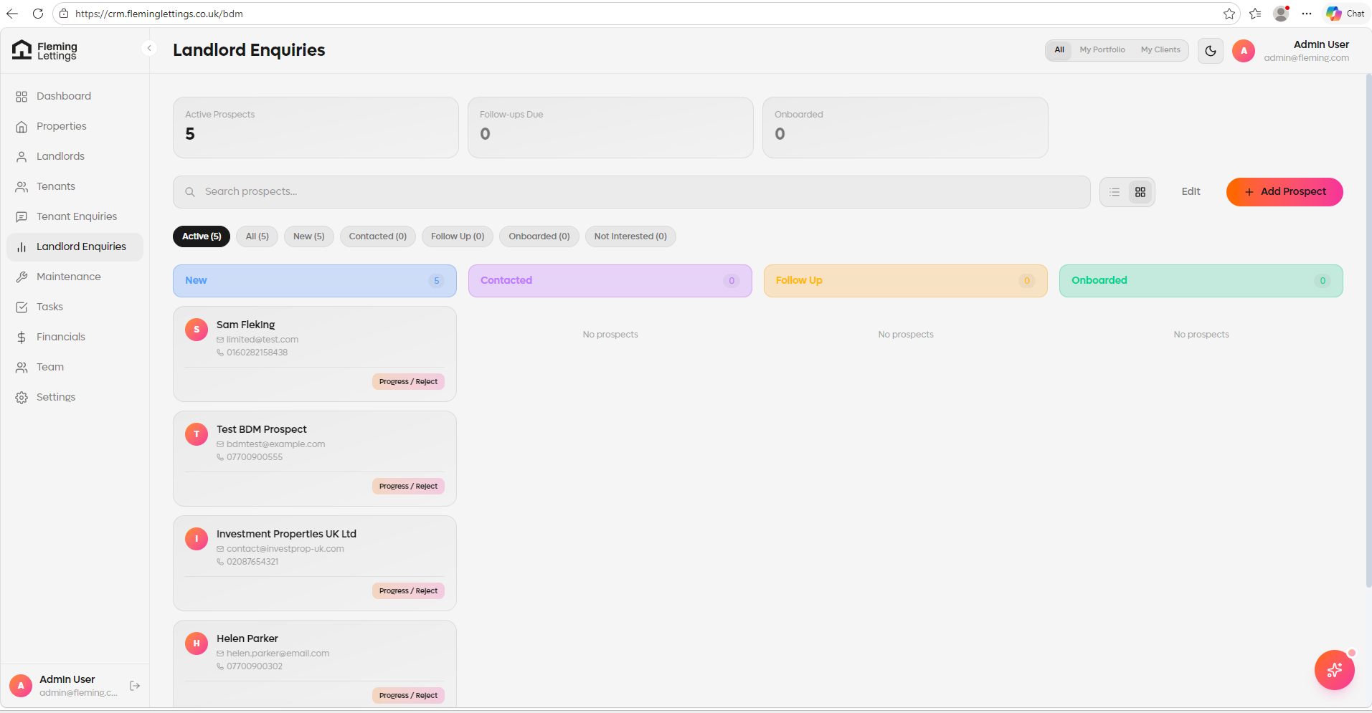
The view should load like this.

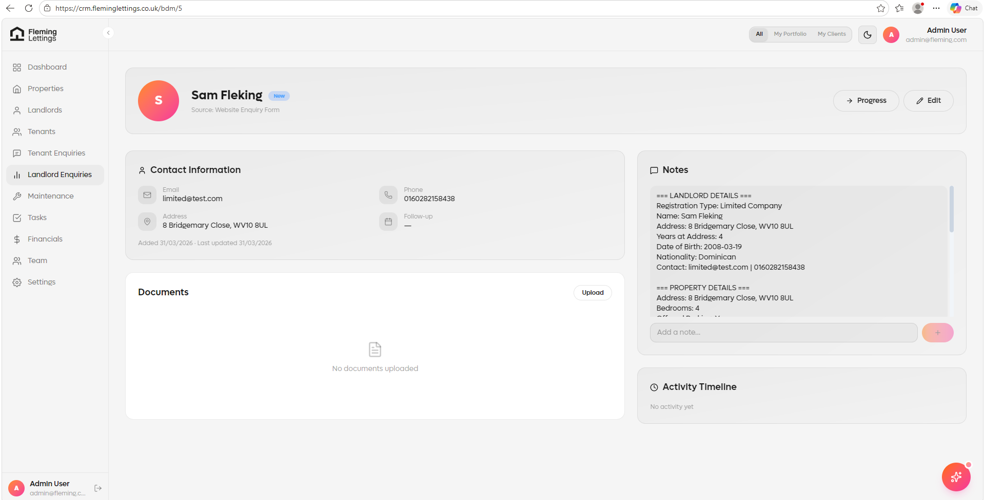
Activity tracking is not working – i.e. I have just viewed the record and no log has been left.

Page layout is missing the SMS functionality. Please ensure that this is added along with the SMS tracking.
The email out records should also be showing as well so we have an audit of all emails sent out to the client. This should be under the SMS section on the page.



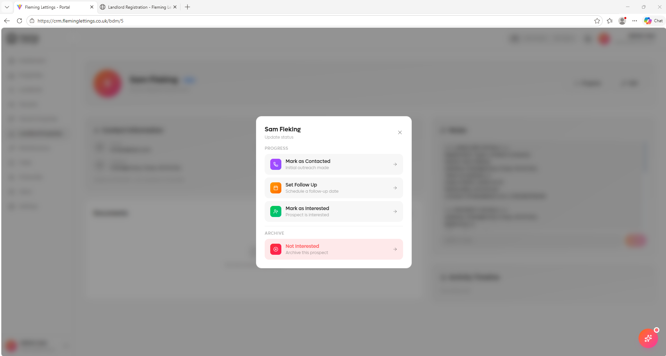
None of the stages are functional and do not work when clicked on.
Stages that should be on here are:
Set Follow Up – this should work the same as on the tenant enquiry pages. The follow up should again have a SMS automation function on it so the user can issue a SMS from the follow up screen.
Onboard – this then moves the record into the Landlord module, copying over ALL information, records, logs and activities, plus SMS and email out records.
Not Interested – this then rejects and closes the record and takes it out of the view.

